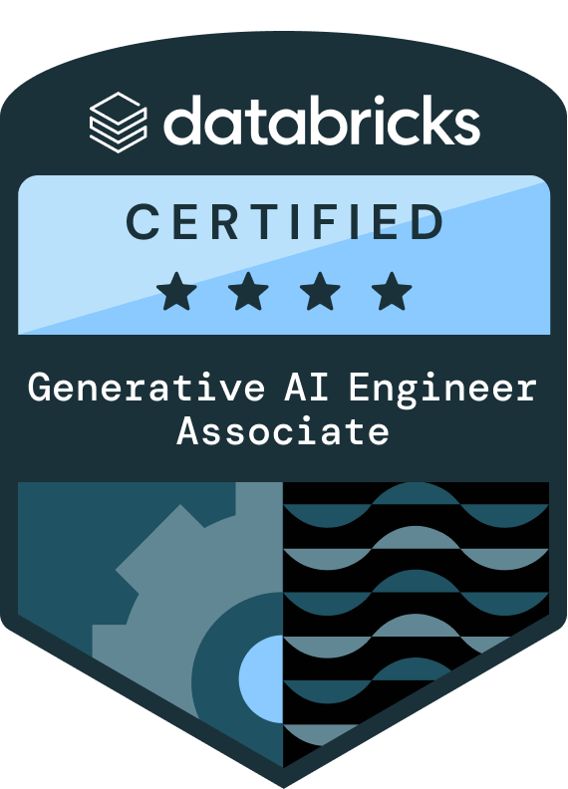
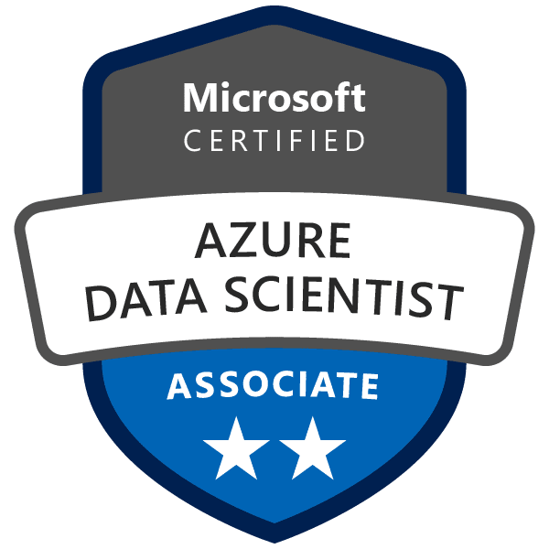
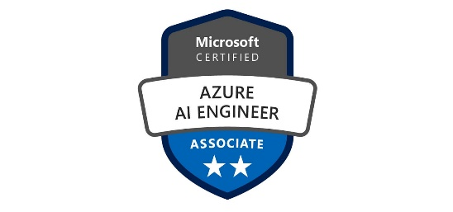
Vaishnavi Ginna
Data Scientist
Phone: 469-294-1336
Email: vaishnavi.ginna23@gmail.com
LinkedIn: https://www.linkedin.com/in/vaishnavi-reddy-ab0672183/

PROFESSIONAL SUMMARY:
- Experienced Data Scientist and Data Engineer with over 12 years in the IT industry, specializing in the design and implementation of scalable, cloud-native data and AI solutions. Expert in developing intelligent agents using frameworks like LangChain, LlamaIndex, and LangGraph, and integrating them with enterprise data platforms to drive intelligent automation and decision-making. Proficient in building robust ETL pipelines, managing end-to-end ML workflows, and working across Azure and AWS ecosystems. Adept at transforming complex data environments into actionable insights through advanced analytics and AI-powered solutions.
- Delivered enterprise-scale GenAI solutions using GPT-4, LangChain, and FAISS, including fraud case summarization, semantic search, and compliance-aligned LLM apps.
- Built and deployed ML and GenAI pipelines on Azure ML, Synapse Analytics, and GCP Vertex AI, incorporating CI/CD, model monitoring, and auto-scaling capabilities.
- Deep experience in Natural Language Processing (NLP), including NER, sentiment analysis, text summarization, and clinical documentation automation using Transformers, spaCy, and Hugging Face.
- Hands-on with MLOps & LLMOps practices, including model versioning, prompt orchestration, token usage tracking, retrieval-augmented generation (RAG), and REST-based deployment.
- Specialized in domains such as credit card fraud detection, loan default prediction, readmission modeling, and churn analytics, driving measurable ROI and compliance.
- Expert in feature engineering from high-dimensional sources (e.g., EMR, claims, SDoH, telemetry) using PySpark, Delta Lake, and SQL to support scalable model development.
- Proficient in explainability frameworks such as SHAP, LIME, with a strong understanding of GDPR, PHI masking, and AI governance frameworks.
- Experienced in Big Data technologies, including Apache Spark, Kafka, Hive, and Delta Lake, with expertise in vector databases like FAISS and Pinecone.
- Effective in cross-functional collaboration across data engineering, analytics, governance, and DevSecOps teams to convert complex business needs into deployable ML solutions.
- Delivered executive-ready dashboards using Power BI and Tableau to visualize AI/GenAI KPIs, risk scores, and operational insights.
- Regularly presented AI/ML/GenAI roadmaps and outcomes to C-suite and compliance teams, driving strategic alignment and project funding.
- Committed to continuous learning and upskilling in LLMs, self-supervised learning, multi-modal AI, diffusion models, and responsible AI practices.
- Conducted A/B testing and model performance monitoring using Python and Airflow, improving customer engagement by analysing the impact of predictive analytics.
- Utilized SQL to extract and analyze large datasets from Azure SQL Database and BigQuery, providing actionable insights into sales trends and improving forecasting models.
- Worked with unstructured data to build text classification models using NLP techniques, enhancing document parsing capabilities for real-time analysis in machine learning models.
- Developed data ingestion processes and maintained data quality for consistent, efficient integration into Azure Machine Learning, enabling reliable and accurate data processing pipelines.
- Used Python and Airflow to automate data extraction, transforming raw data into structured datasets for ML model development, improving data efficiency for predictive models.
- Created interactive visualizations in Power BI to communicate insights from ML model outputs, improving decision-making by presenting clear, actionable data to stakeholders.
- Enhanced model interpretability by applying SHAP and LIME to explain model decisions and improve transparency for business users, ensuring trust in AI at all levels of operations.
- Led model deployment using Azure ML Studio, optimizing data flow and ensuring model scalability for predictive analytics in production environments.
- Automated data pipeline workflows using DBT and Python, reducing manual data processing time and enabling real-time updates to data lakes for more accurate model outputs.
- Performed statistical analysis and developed predictive models for customer retention, using logistic regression and random forests, improving retention strategies for business clients.
- Built and tuned classification models using XGBoost, scikit-learn, and Python to identify key customer segments for targeted marketing, resulting in increase sales conversion.
- Delivered model performance monitoring solutions using Data Robot, tracking ML model effectiveness and providing insights for continuous improvement to optimize predictive models.
- Designed data pipelines to integrate legacy systems and modern data platforms, ensuring efficient data flow for machine learning model integration, improving data accessibility.
- Conducted EDA to identify trends, outliers, and relationships in data, providing critical insights for developing high-performing machine learning models for client applications.

TECHNICAL SKILLS
- Programming Languages: Python, Java, ReactJS, Angular, Next.js, HTML, CSS, C, R, SQL, PySpark
- Machine Learning: Supervised Learning, Unsupervised Learning, Model Evaluation Metrics, Cross-Validation, Feature Engineering, Hyperparameter Tuning, Overfitting & Regularization (L1, L2), Decision Trees, Random Forest, XGBoost, LightGBM.
- Deep Learning: Artificial Neural Networks (ANN), Convolutional Neural Networks (CNN), Autoencoders, VGG, ResNet, Attention Mechanism, YOLO, Faster R-CNN, OCR, U-Net, Mask R-CNN.
- Natural Language Processing (NLP): Tokenization, Lemmatization, Stemming, Bag of Words (BoW), TF-IDF, Word2Vec, GloVe, FastText, Sequence-to-Sequence Models, Recurrent Neural Networks (RNN), Long Short-Term Memory (LSTM).
- Application/Web Server: Apache Tomcat, WebSphere, WebLogic.
- Generative AI: LLMs, Ollama, LangChain, LangSmith, Agentic AI, LoRA, QLoRA, Llama, Gemma, Groq, Nvidia NIM, Retrieval-Augmented Generation (RAG), Neo4j, Chroma, Pinecone.
- MLOps & LLMOps: CI/CD for ML, Model Deployment (REST API, Batch), Model Monitoring, Model Versioning, Model Retraining Pipelines, ML Pipelines (MLflow, Airflow, Kubeflow), Experiment Tracking (MLflow, Weights & Biases), Data Versioning (DVC), Logging and Alerting (Prometheus, Grafana).
- Big Data: Hadoop, Hive, HBase, Apache Spark, Scala, Kinesis, Pig, Sqoop.
- Azure services: Azure Machine Learning, Azure Synapse Analytics, Azure Data Lake Storage Gen2, Databricks, Azure Data Factory, Azure Blob Storage, Azure SQL Database, Azure Cosmos DB, Azure Key Vault, Azure DevOps, Azure Monitor, Azure Purview.
- Amazon Web Services: EC2, Lambda, SageMaker, Bedrock, EMR, S3
- Google Cloud Platform(GCP): Vertex AI, AutoML, Dialogflow, Vision AI, BigQuery, Dataflow, Dataproc, Pub/Sub, Data Fusion.
- Database Servers: MySQL, Mongo Microsoft SQL server, SQLite, Redhift, RDS, PostgreSQL, SQLAlchemy, Mongo DB, Teradata
- Web Technologies: HTML, XML, Servlets, JSP, Web Services, AJAX, JQuery.
- Other Tools & Technologies: Git, GitHub, GitLab, Docker, Kubernetes, CUDA Toolkit, Postman, REST APIs, Terraform, Jenkins, Power BI, Tableau.

EDUCATION:
- Bachelor of Technology in Computer Science and Engineering from St.Martin’s Engineering College completed in May 2013

CERTIFICATIONS:
- Databricks Certified Generative AI Engineer Associate.
- Microsoft Azure Data Science Associate.
- Microsoft Azure AI Engineer Associate.

WORK EXPERIENCE:
Optum Minneapolis, MN
Data Scientist
Feb 2025 to present
Roles & Responsibilities:
- Built a GenAI-powered fraud case summarization engine using GPT-4 and LangChain, converting multi-source fraud signals into concise investigator-ready narratives.
- Designed real-time fraud detection models using XGBoost and LightGBM, flagging anomalies in transaction sequences and behavioral patterns with precision.
- Created semantic vector databases using FAISS and Azure OpenAI embeddings, enabling retrieval-augmented generation (RAG) for financial compliance Q&A.
- Integrated prompt engineering layers to support variable summarization styles (legal vs. investigator), improving review efficiency.
- Developed a fine-tuned credit transaction classifier using BERT variants, achieving high F1-scores in identifying chargeback categories.
- Collaborated with governance and compliance teams to implement GenAI PHI masking, GDPR filters, and access control policies for auditability.
- Presented GenAI frameworks and outcomes to executive and audit committees, driving stakeholder alignment and funding for next-gen AI initiatives.
- Built real-time healthcare dashboards in Power BI using AWS Redshift and S3, providing actionable insights into patient care gaps for healthcare teams.
- Led data migration from SQL Server to AWS Redshift, improving data warehousing for faster healthcare reporting and more efficient data processing.
- Implemented AWS security best practices, including data encryption and IAM roles, to ensure the safe handling of sensitive patient information across AWS infrastructure.
- Leveraged Fiddler AI to provide detailed model insights and explanations of healthcare AI algorithms, increasing trust and understanding of AI-driven decisions among stakeholders and healthcare providers.
- Automated the data migration process from SQL Server to Snowflake using AWS Glue, reducing manual intervention and improving the speed of patient data integration.
- Built real-time data processing workflows using AWS Lambda and Kinesis to enable seamless integration of patient health data across systems, improving data flow for operations.
- Led the integration of FHIR-compliant data into AWS S3, transforming it with AWS Glue and loading into Redshift for analytics, improving care coordination and patient outcomes.
- Collaborated with business teams to define data migration timelines and milestones for Salesforce to Dynamics 365, ensuring smooth transitions and no interruptions to sales operations.
- Utilized Fiddler AI to monitor AI models' performance in real-time, providing insights into model behavior and ensuring consistent alignment with HIPAA compliance and patient data security requirements.
- Performed data validation and quality assurance on patient care datasets, ensuring accuracy and consistency in AWS Redshift and Looker for care gap analysis.
- Developed automated reporting solutions using AWS Glue, Redshift, and Power BI, providing real-time insights into patient care and clinical workflows.
- Optimized data transformation workflows using Spark and Databricks for patient care and claims data, improving data processing efficiency and reducing cycle time.
- Integrated Fiddler AI with patient care models, enhancing model explainability and improving AI-driven healthcare decisions, ensuring transparency and trust in predictive models for care gap analysis.
- Developed SQL scripts for processing patient care data in AWS Redshift, ensuring accurate reporting and enabling real-time insights into care gap metrics for teams.
- Led healthcare data migration efforts for Salesforce to Dynamics 365, collaborating with PdMs and data teams to ensure seamless integration and data accuracy during migration.
- Implemented data transformation pipelines in AWS Glue to migrate clinical data from Teradata to Snowflake, improving data quality and enabling better reporting capabilities.
- Optimized patient care data models using AWS Redshift and Databricks, improving data processing and reporting for real-time health insights.
- Created custom reports in Looker to track patient care gaps and clinical data, enabling data-driven decisions for healthcare teams and improving patient outcomes.
- Applied Fiddler AI to analyze and improve the interpretability of machine learning models used in patient care prediction, enhancing healthcare outcomes through better understanding of model decisions.
- Supported post-go-live support by resolving technical issues in healthcare data reporting during Hyper Care, ensuring patient care data accuracy and smooth integration with Redshift.
Environment: AWS (S3, Redshift, Glue, Lambda, Step Functions, CloudWatch, Data Pipeline, EMR, Athena, SageMaker), Azure (Data Factory, Synapse Analytics, SQL Database, Databricks), Databricks (Delta Lake), Snowflake, Kafka, Flink, Power BI, QuickSight, HIPAA, HEDIS, NCQA.

Central Hudson Kingston, NY
AI Engineer
Sep 2019 to Feb 2025
Roles & Responsibilities:
- Led data migration from Salesforce to Dynamics 365, ensuring seamless integration of sales data, inventory records, and customer insights, improving retail operations.
- Developed ETL pipelines using Azure Data Factory to ingest sales data from SQL Server into Azure Synapse, providing real-time reporting and sales insights.
- Designed and optimized Looker dashboards for sales trends, inventory management, and customer behavior, enabling data-driven decisions and improving retail operations.
- Implemented Fiddler AI to monitor the explainability and performance of customer behavior models, improving sales predictions and enhancing the effectiveness of targeted marketing campaigns.
- Built real-time reporting solutions using Azure Synapse and Power BI, improving sales performance tracking and optimizing inventory management.
- Implemented data transformation processes using SQL and Python to migrate retail sales data from Salesforce to Dynamics 365, ensuring smooth data integration.
- Developed custom SQL queries for sales analysis and inventory optimization, improving the accuracy of real-time reporting for retail teams.
- Coordinated data migration from Salesforce to Dynamics 365, mapping field data and ensuring compatibility with retail reporting systems.
- Applied Fiddler AI's monitoring tools to track model performance and drift in sales forecasting models, allowing organization to maintain accurate predictions and enhance retail operations.
- Integrated Azure Blob Storage with SQL Server for real-time data synchronization between Salesforce and Dynamics 365, ensuring accurate retail operations data.
- Supported data governance and data integrity by implementing data quality checks in SQL Server and Azure Synapse, ensuring sales data accuracy.
- Developed automated reporting solutions using Azure Data Factory and SQL, reducing the time spent on manual reporting and enhancing sales visibility.
- Improved inventory tracking by creating real-time reports using Looker and SQL, providing actionable insights for store managers.
- Led data migration from SQL Server to AWS Redshift, optimizing data storage and improving reporting speed for sales and inventory.
- Designed and implemented ETL workflows using AWS Glue to integrate sales data from SQL Server and Teradata into Redshift, enabling real-time reporting for business intelligence.
- Built and deployed data pipelines using AWS Lambda for real-time sales reporting, improving the accuracy and speed of sales forecasting.
- Optimized SQL queries for inventory management and sales forecasting, improving data retrieval speed and enhancing reporting accuracy.
- Developed data transformation workflows using Python and AWS Glue to migrate sales data from SQL Server to Redshift, ensuring smooth data integration for operations.
- Created Power BI dashboards for tracking sales performance and inventory turnover, providing real-time insights into retail operations and improving decision-making.
- Integrated AWS Redshift with Power BI, providing executive dashboards for sales reporting and inventory management, improving business intelligence.
- Implemented data validation and quality checks in AWS Glue to ensure sales data and inventory reports were accurate, improving reporting efficiency.
- Designed SQL-based reports for sales performance tracking and inventory optimization, enabling business analysts to gain actionable insights for better store performance.
- Led data quality assurance processes for sales data migration into Redshift, ensuring data consistency and improving reporting speed for operations.
- Created automated data pipelines for sales forecasting, using AWS Glue and Redshift, improving real-time reporting and increasing forecasting accuracy.
- Designed data models in AWS Redshift for product sales and inventory management, improving forecasting accuracy and enabling efficient store replenishment at stores.
- Automated inventory management reports using AWS Glue, Redshift, and Lambda, improving sales performance and reducing manual data entry for operations.
- Developed real-time sales analysis reports using AWS Lambda and Redshift, enabling faster access to sales data and improving business intelligence.
- Led post-migration testing for sales data from Teradata to AWS Redshift, ensuring data consistency and improving reporting accuracy for operations.
- Implemented data transformations using AWS Glue and Python, ensuring that sales data from SQL Server and Teradata was accurately migrated to Redshift for improved analytics.
- Optimized inventory management systems using AWS Redshift and Looker, providing real-time reporting on sales trends and improving product availability.
Environment: Azure (Data Factory, SQL Database, Synapse Analytics, Event Hubs, Data Lake, Databricks, Power BI), AWS (Redshift, S3, Glue, Lambda, QuickSight, Athena), GCP (BigQuery, Dataflow, Cloud Functions), Kafka, Looker, Tableau, PySpark, Scala, SQL, GDPR, HIPAA, Retail Data.

Oracle Financial Services Software, India
Data Analyst
Feb 2015 to April 2017
Roles & Responsibilities:
- Developed ETL pipelines using Azure Data Factory and Azure Synapse Analytics to integrate sales data from SQL Server and Teradata, improving reporting accuracy and operational efficiency for retail teams.
- Designed and optimized Power BI dashboards for inventory tracking, sales forecasting, and product performance, enabling real-time reporting and enhancing business decision-making.
- Built custom SQL queries for sales reporting, inventory analysis, and product trends, delivering real-time insights into retail operations and improving inventory management.
- Implemented real-time data pipelines using Azure Functions and Azure Event Hubs for sales and inventory data, increasing data flow efficiency and accelerating reporting timelines.
- Automated data extraction from SQL Server and Teradata into Azure Synapse Analytics using Azure Data Factory, reducing manual workloads and boosting report delivery speed.
- Enhanced inventory reporting by developing SQL scripts and Power BI dashboards, offering actionable insights for store managers and optimizing stock replenishment processes.
- Led data migration from Teradata to Azure Synapse Analytics, improving data storage, query performance, and reporting scalability across business units.
- Designed and implemented scalable ETL workflows using Azure Data Factory to integrate enterprise sales data sources into Synapse for centralized analytics.
- Built and deployed real-time data pipelines using Azure Functions to support near real-time sales forecasting and data-driven decision-making.
- Optimized SQL queries for sales forecasting and inventory operations, enhancing query efficiency and improving analytical turnaround times.
- Developed data transformation workflows using Python and Azure Data Factory, ensuring seamless integration of sales data into Synapse with reliable schema mapping.
- Created and maintained Power BI dashboards to track sales performance and inventory turnover, enabling data-driven decisions in real time.
- Integrated Azure Synapse Analytics with Power BI to deliver executive dashboards for sales and inventory management, enhancing enterprise BI capabilities.
- Implemented data validation and quality checks in Azure Data Factory to ensure high data integrity for reporting and analytics.
- Designed and delivered SQL-based reports for sales performance and inventory optimization, enabling analysts to act on timely and actionable insights.
- Created automated data pipelines for sales forecasting using Azure Data Factory and Azure Synapse, increasing forecast accuracy and reducing latency.
- Designed data models in Azure Synapse Analytics to support product sales analysis and inventory management, improving accuracy in forecasting and replenishment.
- Automated inventory management reports using Azure Data Factory, Azure Synapse, and Azure Functions, improving operational efficiency and reducing manual work.
- Developed real-time analytics reports using Azure Functions and Synapse, enabling faster access to sales metrics and business performance tracking.
- Conducted end-to-end testing and validation post-migration from Teradata to Azure Synapse, ensuring report consistency and high data fidelity.
- Implemented complex data transformations in Azure Data Factory using Python, enabling efficient migration and analytics integration from SQL Server and Teradata.
- Improved inventory management systems through data modeling in Azure Synapse and visualizations in Power BI, delivering actionable reporting on sales trends.
- Developed automated pipelines for real-time reporting using Azure Data Factory and Azure Functions, streamlining data flow and reporting operations.
- Enhanced sales data processing by building SQL automation scripts to support inventory tracking and sales forecasting, improving data pipeline efficiency.
- Led Salesforce data migration into Azure Synapse, ensuring smooth integration and accurate reporting for sales analytics.
- Designed SQL-based data transformation scripts to integrate Salesforce data with Azure Synapse, enhancing reporting quality and model readiness.
- Refined data modeling approaches in Azure Synapse and Power BI to improve reporting insights and support inventory optimization.
- Built SQL queries to analyze sales trends, customer behavior, and inventory KPIs, enabling informed strategic decisions.
- Directed data integration efforts using Azure Synapse Analytics, boosting reporting accuracy and performance across retail datasets.
Environment: Azure Databricks, Azure Data Factory, Azure Blob Storage, Azure SQL Database, Azure Cosmos DB, Azure Cognitive Services, Azure HDInsight, Azure Kubernetes Service (AKS), Azure Functions, Azure Event Hubs, Azure Stream Analytics, Azure Container Registry, Azure App Service, Azure Key Vault, Azure DevOps, Azure Monitor, Azure Purview, Snowflake, Kafka, Power BI, Python, Scala, SQL, PySpark.

L&T Technology Services, India
Data Engineer
July 2013 to January 2015
Roles & Responsibilities:
- Created structured fraud intelligence reports using SQL and Oracle for transaction monitoring teams, tracking KPIs such as anomaly rate, alert volumes, and rule accuracy.
- Developed audit-ready fraud datasets by working with ETL engineers to extract, transform, and aggregate high-risk transaction feeds across interbank sources.
- Automated daily and weekly reporting cycles using PL/SQL scripts and scheduling via UNIX shell jobs, reducing reporting latency.
- Participated in re-architecting Informatica workflows by providing metric definitions, business rule mappings, and QA test plans.
- Worked alongside the compliance team to implement data integrity checks and validation scripts, ensuring consistency across operational and regulatory datasets.
- Conducted root-cause analysis on discrepancies in fraud scoring results by tracing upstream data lineage and historical audit trails.
- Documented fraud pattern KPIs and data lineage models, helping data scientists and BI developers access clean, well-defined source layers.
- Contributed to cross-functional meetings with fraud modelers, ETL developers, and QA testers to align reporting with fraud detection thresholds.
Environment: Python (Scikit-learn, XGBoost, Pandas, NumPy), SQL, Snowflake, Power BI, Streamlit, Jupyter, Fraud Analytics, SQL, Oracle, PL/SQL, Informatica PowerCenter, Claims Scoring, Policy Lapse Prediction, Regulatory Reporting, Model Explainability.

